**Ford Motor Company**

***Corporate Sponsors***

Adam Haas

Dearborn, Michigan

Michael Seneski

Dearborn, Michigan

Michael Volk

Dearborn, Michigan



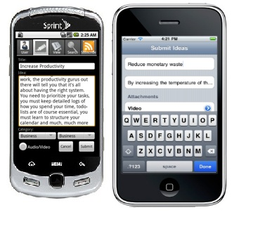

A company's most important assets are its employees and their ideas. In order for employees to document and share these ideas, Ford has developed an online application called Ford Idea Place.

Ford employees work at many locations, including at manufacturing plants and at supplier facilities. When someone gets an idea at such a location, say on a plant floor, they may not have access to Ford Idea Place. By the time access is available, the idea may be lost.

To address this issue, Ford partnered with Michigan State University, tasking a team of students with developing a mobile solution that is built on Ford Idea Place. The result is Ford Idea Place Mobile Edition.

Ford Idea Place Mobile Edition consists of two custom apps, one for the iPhone and one for the Android, which allow users to share ideas anytime, anywhere. It features the ability to post, view, rate and comment on ideas. Users can even subscribe to authors and categories to keep them updated with ideas that could impact their work stream. As added incentive, users are also awarded achievements for various milestones like posting their first idea.

Further expanding its capabilities, the application can use the device's physical resources to attach photos, audio or video to ideas. Such functionality allows users to capture an idea fully while the platform's mobility allows these features to be accessed from anywhere, any time.

**Michigan State University**

***Team Members*** (left to right)

Derek Ulch

Holt, Michigan

Josh Kitchens

Ann Arbor, Michigan

Victor Kupatavetin

Bangkok, Thailand

Sam Djap

Jakarta, Indonesia



**Ford Motor Company**

**Ford Idea Place Mobile Edition**