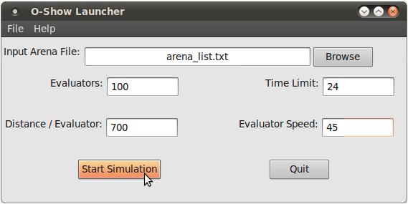

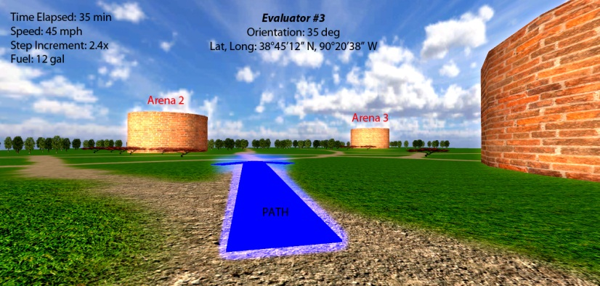

**The Boeing Company**

***Corporate Sponsors***

Pete Clive

Saint Louis, Missouri

Matt Daniels

Saint Louis, Missouri

Jayson Vincent

Saint Louis, Missouri

Steve Yallaly

Saint Louis, Missouri



The Boeing O-Show project is a joint effort between Michigan State University and The Boeing Company to develop specialized software to find and simulate an optimized path for multiple units traveling to a large number of destinations. O-Show stands for “Optimize and Show.”

O-Show is best understood with an illustrative example of how it might be used. Imagine that there are many evaluators who are tasked to evaluate certain properties of basketball arenas in a given state within a given timeframe.

In this scenario, our software allows the user to configure: evaluator travel speed, number of evaluators, a starting point, maximum allowed evaluator travel distance, and a list of arenas to visit. The main goal is to optimize the routes of the evaluators in a way that minimizes the number of them need to accomplish the mission.

The software comprises two parts. First, a launcher takes the inputs for the desired problem. The launcher then feeds the inputs to lp_solve, which is a software library used for solving linear programming models. The launcher then receives the results of lp_solve’s calculations, completing the “Optimize" part of our simulation. After that, our “Show” aspect of the simulation takes over.

“Show”—the visualization—is written in a graphics library called OpenSceneGraph and is used to render a graphical representation of the people, places, and paths of our simulation.

**Michigan State University**

***Team Members*** (left to right)

Matthew France

Jackson, Michigan

Scott Buffa

Oakland, Michigan

Bryan Askins

Farmington Hills, Michigan

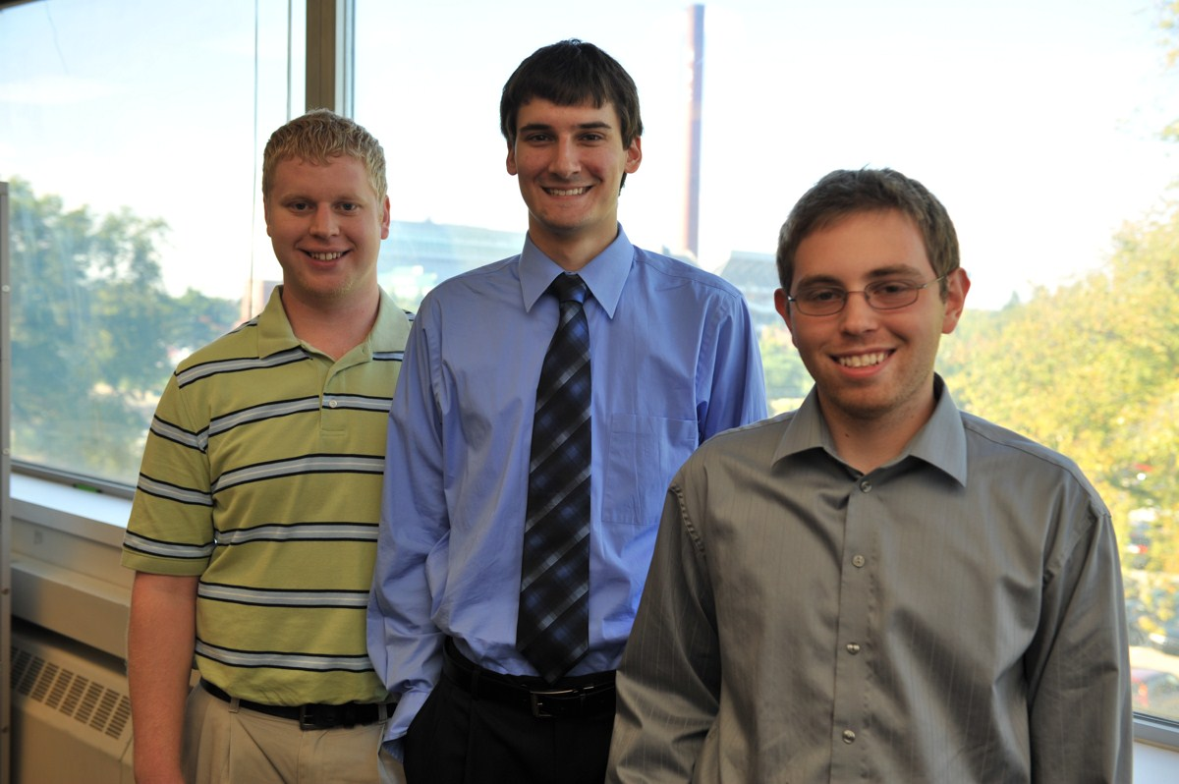

**The Boeing Company**

**O-Show for Simulation Software**