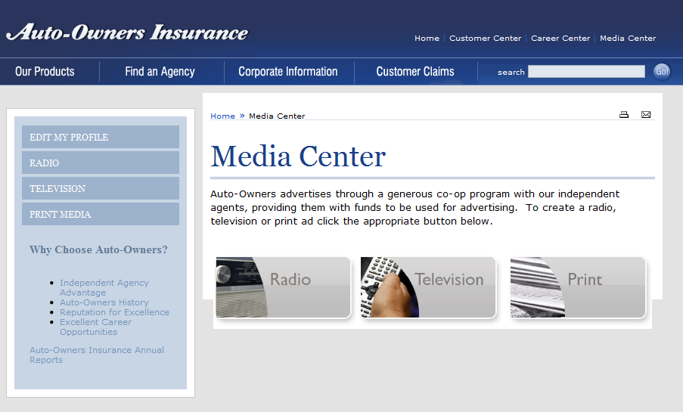

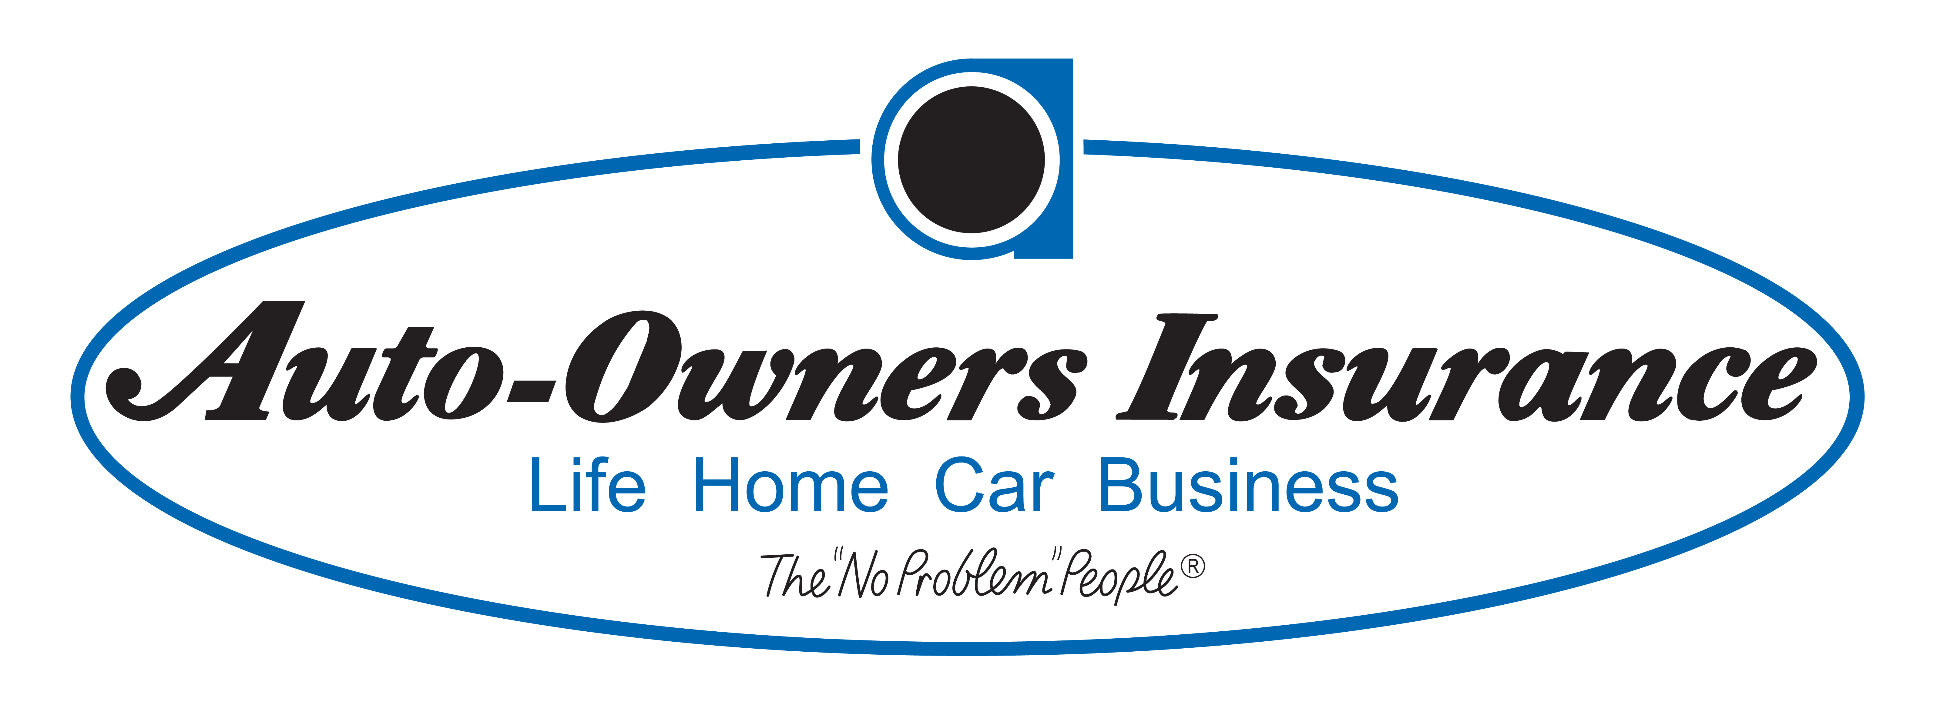

**Auto-Owners Insurance**

***Corporate Sponsors***

Bob Buchanan

Lansing, Michigan

Megan Collins

Lansing, Michigan

Scott Lake

Lansing, Michigan

Auto-Owners Insurance provides many different advertising resources to their independent agents. A significant part of this service involves a set of templates of ads, which are available to their agents via their web-based Media Center.

In order to make this process easier for both parties, we have created a web application, the Agent Multimedia Ad Builder, that allows agents to create print, TV, and radio ads that are specific to their agency.

The web application allows agents to create profiles with basic information such as agency name and location, which is then automatically incorporated into one of the ad templates. This process makes customization much more convenient since agents simply need to pick a template they like and all their agency information will be used to create the corresponding ad.

For agents that like to include their own touch of editing into the ads, we have created a basic web editor for print ads that lets them drag and drop different pictures into the template. The editor also allows them to edit the written content in place on the ad.

All of the created ads are able to be previewed and saved for later visits through the application. Ads that are complete and ready for submission will be able to be sent for approval by Auto-Owners Insurance to ensure that the ads are cleared for publication.

**Michigan State University**

***Team Members*** (left to right)

Jeff Chapman

Plymouth, Michigan

Michael Kerwin

Howell, Michigan

Marie Buckner

New Baltimore, Michigan

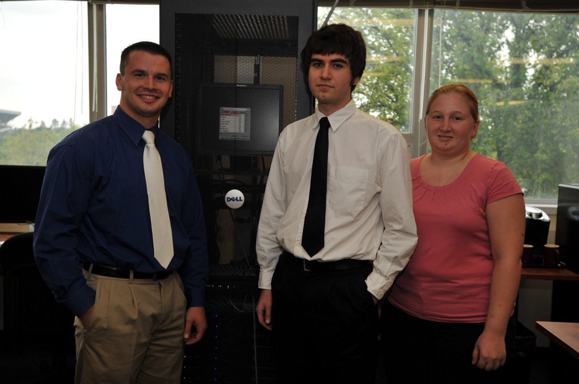

**Auto-Owners Insurance**

**Agent Multimedia Ad Builder**