Michigan State University
Project Sponsors
E.J. Dyksen
East Lansing, Michigan
Rob McCurdy
East Lansing, Michigan
Tyler Olsen
East Lansing, Michigan
Spencer Ottarson
East Lansing, Michigan

The nation’s pioneer land-grant university, Michigan State University (MSU) is one of the top research universities in the world. With over 50,000 students, MSU is home to nationally ranked and recognized academic, residential college and service-learning programs.
Our Spartan Experience App (SEA) is a mobile app that provides useful information for both students and visitors to enhance their MSU experience.
Looking for a bite to eat? SEA shows categorized menus within each dining hall, including dietary restrictions.
Not sure where your first class is? Use our app to search for building locations and get directions.
Visiting and not sure where to park? SEA gives parking locations as well as navigation to get to them.
Wondering when the next football game is? Our app notifies users of current and upcoming events and keeps them connected with a live Twitter feed.
SEA’s personalized home view provides relevant and contextual information based on the user’s location and time of day. Users see nearby dining halls and are alerted to upcoming events. A countdown timer helps students avoid being late to their next class.
Our SEA: Spartan Experience App is developed with Swift for iOS platforms and Java for Android platforms. The AWS Lambda API is written in Python and uses PostgreSQL as the underlying database.

Michigan State University
Team Members (left to right)
Scott Swarthout
Farmington Hills, Michigan
Ryan Johnson
Brighton, Michigan
Nayana Kodur
Okemos, Michigan
Patrick Pale
Troy, Michigan
Roy Perryman
Roscommon, Michigan
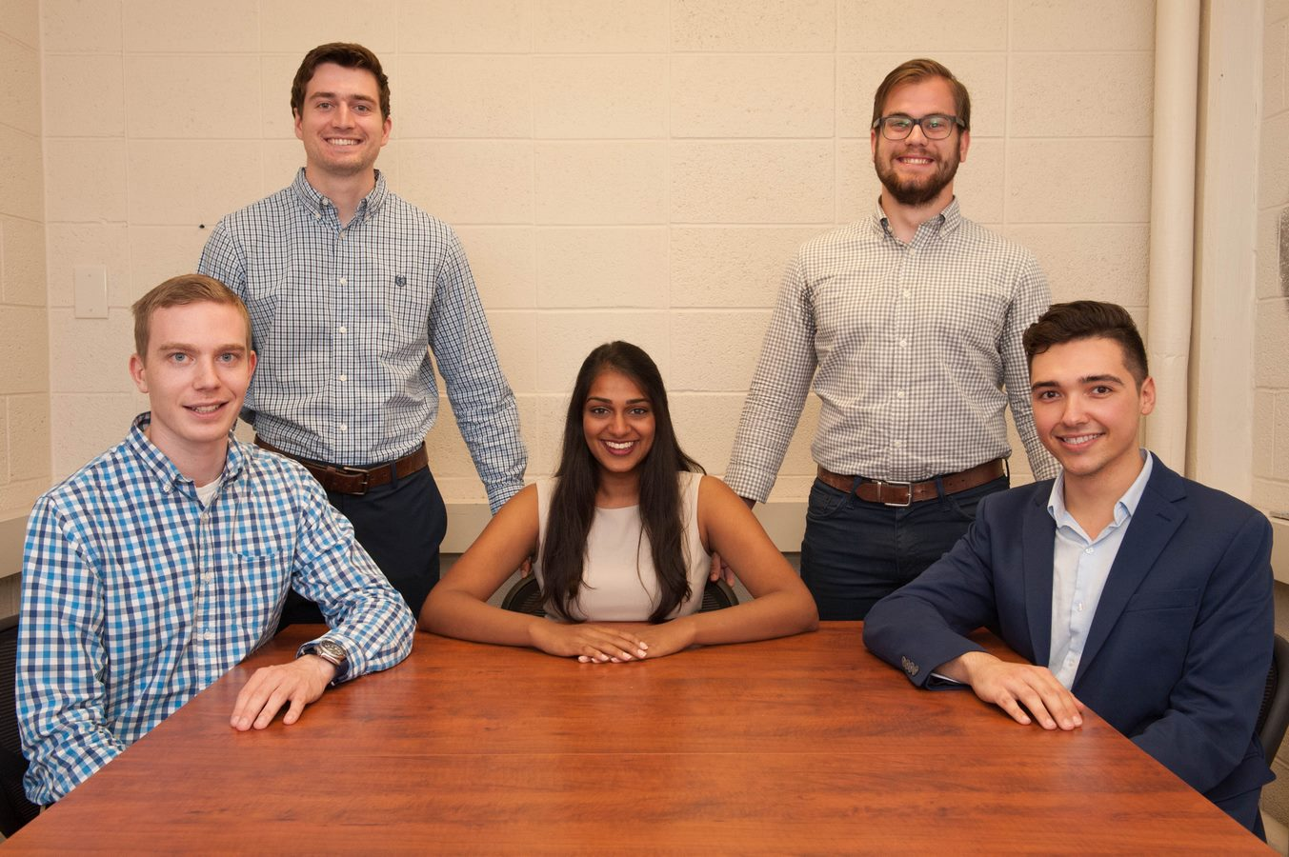
Michigan State University
SEA: Spartan Experience App
.
