Auto-Owners Insurance
Recruiting Contacts and Events System
Auto-Owners Insurance
Corporate Sponsors

Lateresa Baker
Lansing, Michigan
Heidi Dowling
Lansing, Michigan
Mark Hempsted
Lansing, Michigan
Scott Lake
Lansing, Michigan
Fern Shaffer
Lansing, Michigan
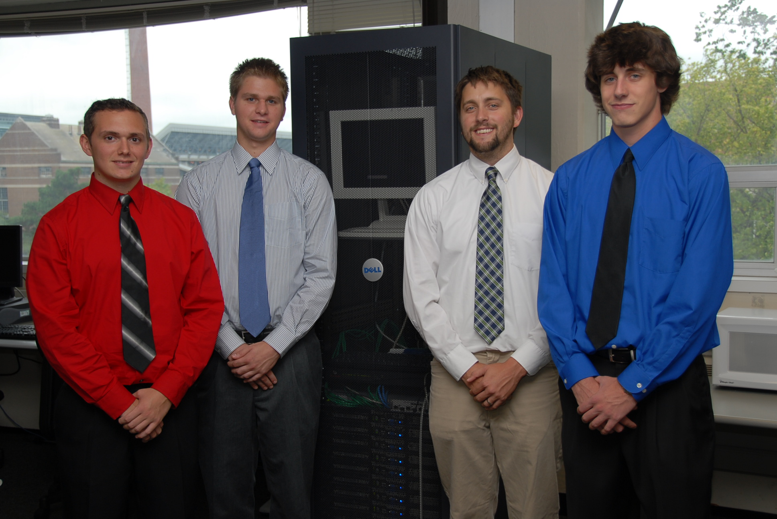
Insert your project description here. Target your writing for high school students. Begin with the motivation for your project. Do not begin with phrases like “Our project was to make…” or “For our project we made…”.
Use a “newspaper” style of writing. Sentences and paragraphs should tend to be short and snappy. It’s even okay to have a paragraph with only one sentence, just not too many of them.
If space permits, you might want to reference your screenshot or diagram at the upper right.
Use 11-point, Times New Roman font. Use single space lines. Justify both margins. Use 6 pts of space between paragraphs; do not use blank lines between paragraphs. Use one space between sentences within a paragraph.
The size of this textbox is 4.1” (wide) by 5” (high). Do not change the size of the textbox. Your text must fit exactly within this textbox with these dimensions. This means that your text should fill the entire textbox but no more.
The last line of each paragraph should be at least one-half to three-quarters of the width of the textbox. Do not end a paragraph with a line containing one or two words.
After you have a draft, make the template available to your clients. Get feedback from them.
The textbox has room for about 225 words. This last sentence fills up the remaining space.
Michigan State University
Team Members
(Left to Right)
Tom Randall
City, State
Mike Korynski
City, State
Ashleigh New
City, State
Jonathan Lindsey
City, State
Insert a project diagram or screen shot here.
This size of this textbox is 3.75” x 3.0”.
The aspect ratio is 1280 x 1024.

