TechSmith Corporation
Rich Media Collaboration
TechSmith Corporation
Corporate Sponsors

Dean Craven
Okemos, Michigan
Tony Lambert
Okemos, Michigan
Randy Schott
Okemos, Michigan
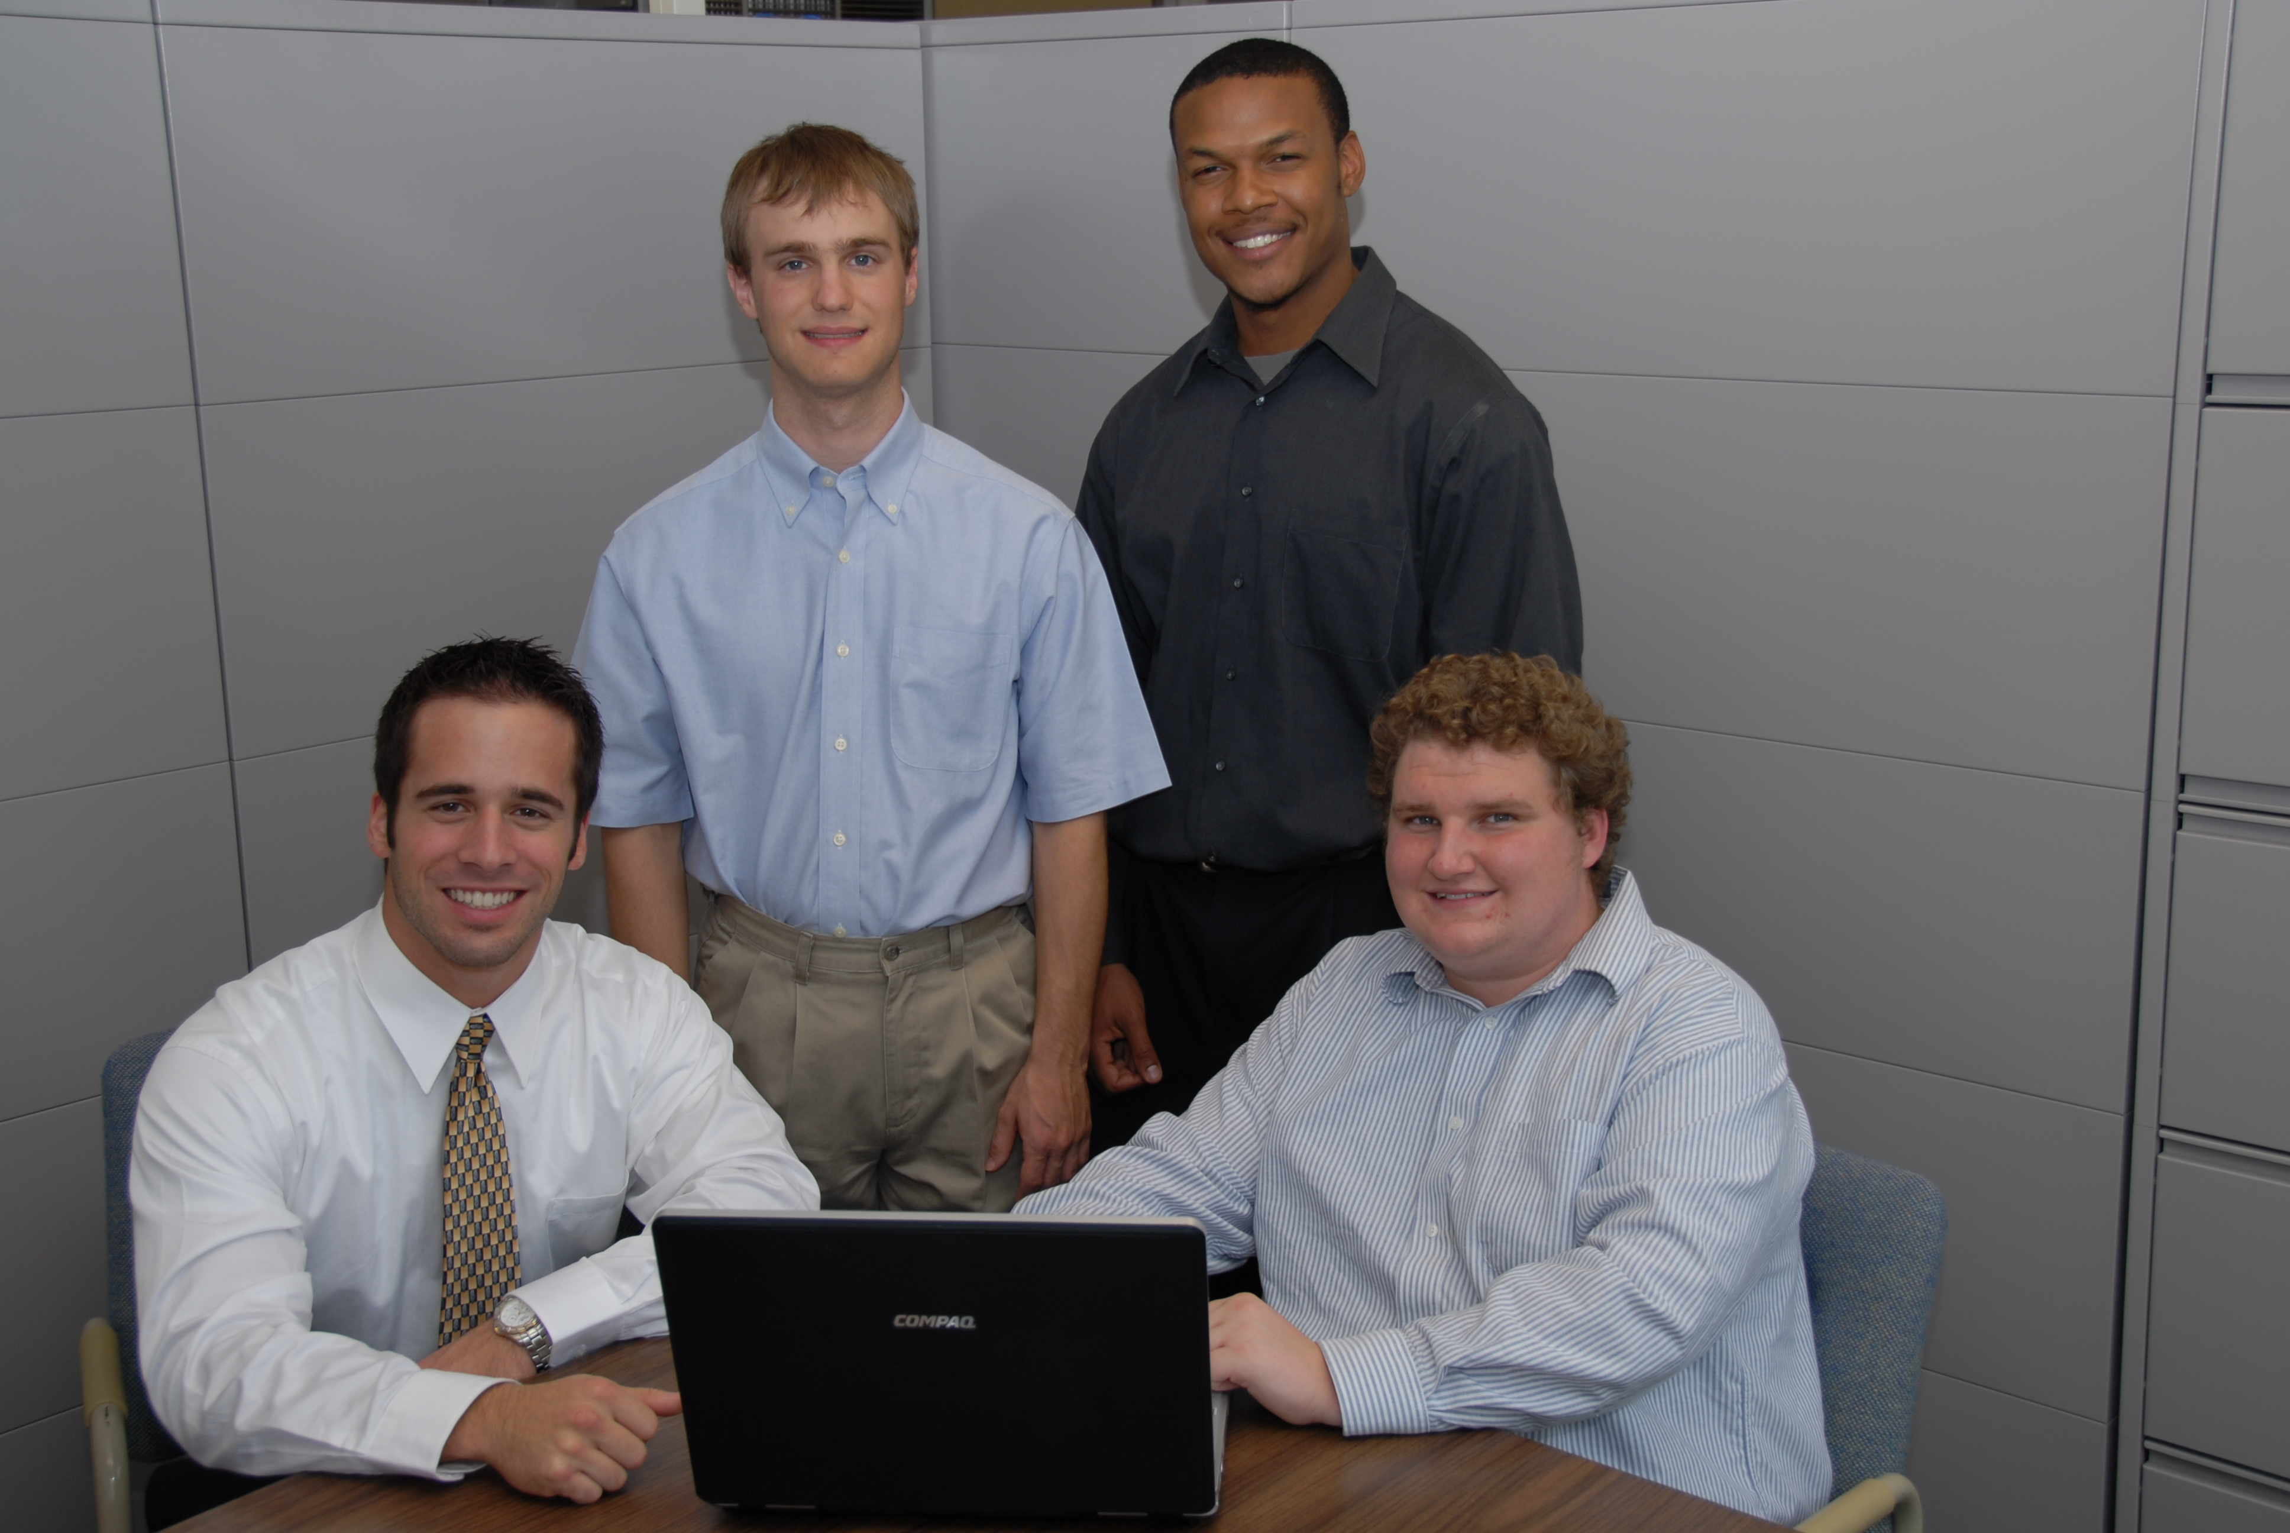
Interception! A devastating turnover has left the announcers with the responsibility of explaining the replay to the audience. With the ability to draw on the screen, the announcers are able to effectively communicate with the viewers what was happening on the field.
Imagine how useful this interaction could be in other situations. A professor might post a lecture video online allowing students to comment, draw, and “tag” directly on the video with any questions or concerns they might have. This type of media interaction is referred to as “deep-tagging,” in which viewers can comment or tag a segment of the video, and even draw on the video at any point in time.
We believe this sort of application to be useful in situations involving instruction or formal presentation and have included a screen recorder to assist users in creating and uploading their own content to the website.
Our player allows for all the basic features of a media player; however, the true power of the application lies in its deep-tagging ability. Using the tagging tools provided, anyone can easily apply text or draw by using predefined shapes or the free hand tool. Once a tag is made, the player saves it to an index alongside the player window. From that point on, the video will play with the newly added content for all to see.
The player utilizes Silverlight, Microsoft’s runtime for rich Internet applications, providing us with the necessary animation, vector graphics, and video playback capabilities.
Michigan State University
Team Members
(Left to Right)
Chris Harter
Holland, Michigan
Tom Lavoy
Dansville, Michigan
Jason Conley
Detroit, Michigan
Brandon Turner
Grand Blanc, Michigan
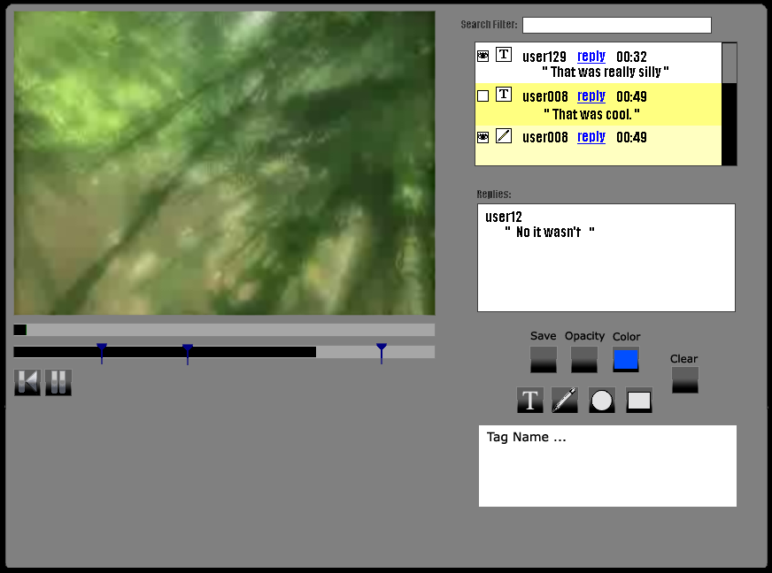
Features
- The ability to draw on the video and add text comments directly on or off the video
- The ability to tag at any time in the video
- The ability to skip directly to a tagged time
- The ability to reply to any tag
- A screen recorder to assist users in creating and uploading their own content

