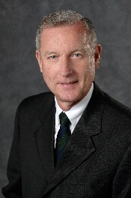
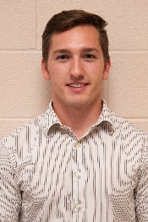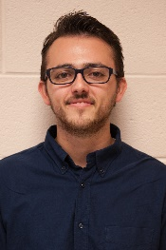
Jonny Dowdall James Mariani
Teaching Assistants
Presentation Schedule – Engineering Building, Room 3405
The Capstone Projects
Dr. Wayne Dyksen
Professor of Computer Science and Engineering
CSE498 Collaborative Design
CSE498, Collaborative Design, provides the educational capstone for all students majoring in computer science. Teams of students build software systems for corporate clients.
During the capstone experience, students
- design, develop, debug, document, and deliver a comprehensive software system,
- work in a team environment,
- develop written and oral communication skills,
- become proficient with software development tools and environments,
- build and administer computer systems, and
- consider issues of professionalism and ethics.
Our clients are local, regional, and national including Amazon, Auto-Owners Insurance, Avata Intelligence, Boeing, Bosch, Chrysler, Electronic Arts, Ford, GE, General Motors, Google, Humana, Meijer, Michigan State University, Microsoft, Mozilla, MSU Federal Credit Union, the Phoenix Group, Quicken Loans, Spectrum Health, Rook Security, Symantec, TechSmith, TWO MEN AND A TRUCK®, Union Pacific, Urban Science, Whirlpool and Yello.
Time | Team | Project Title
7:30 a.m. | Amazon | Faia: Fashion Artificial Intelligence Assistant
7:44 a.m. | Auto-Owners | House of Hazards
7:58 a.m. | Avata | Security Analytics Suite: Configuration Setup Tool
8:12 a.m. | Ford | Ford Smart Parking
8:26 a.m. | GM | Audio Video Workplace Safety System
8:40 a.m. | Humana | MyHumanaBot
8:54 a.m. | Meijer | Meijer Fresh-ipes
9:08 a.m. | Michigan State University | SEA: Spartan Experience App
9:22 a.m. | Microsoft | Enhanced Company Portal with Graph
9:36 a.m. | Mozilla | Taking Firefox Screenshots Testing Suite to 11
9:50 a.m. | MSUFCU | Digital Banking with Chatbots
10:04 a.m. | Phoenix Group | OPEN v2.0: Smart Order Picking
10:18 a.m. | Rook | Cloud Security Event Processing and Alerting Platform
10:32 a.m. | Spectrum Health | Spectrum Health Symptom Checker
10:46 a.m. | Symantec | Secure Application Layer API Proxy
11:00 a.m. | TechSmith | TechSmith Director
11:14 a.m. | TWO MEN AND A TRUCK | Online Moving Estimator
11:28 a.m. | Union Pacific | RailBuilder: The Great Race to Promontory
11:42 a.m. | Urban Science | VDA: Virtual Dealership Adviser
11:56 a.m. | Yello | Automatic Resume Verification

