
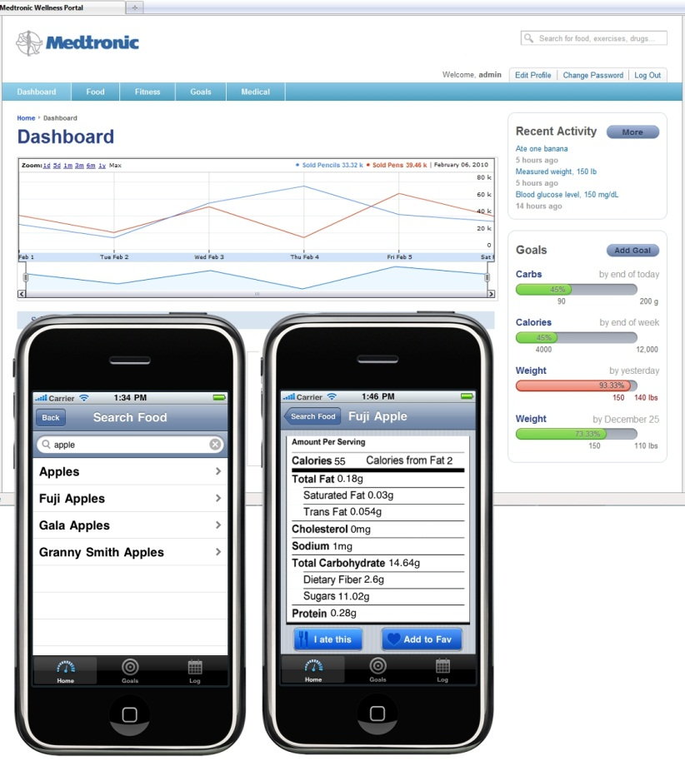
Medtronic, Inc.
Corporate Sponsors
Patrick Agrawal
Mounds View, Minnesota
Peter Erickson
Mounds View, Minnesota
Vandy Johnson
Mounds View, Minnesota
Scott Mark
Mounds View, Minnesota
Javid Masoud
Mounds View, Minnesota
Karin Petty
Mounds View, Minnesota
Michael Studemann
Mounds View, Minnesota

For over 50 years, Medtronic’s mission has been to alleviate pain, restore health, and transform the way the world treats chronic diseases so patients can live a fuller life. To this end, the Medtronic Wellness Portal enables patients to manage their diet, health and activity levels in a streamlined, more convenient way.
The heart of the Wellness Portal is to help a patient understand the impact of their food and exercise choices on their overall wellness. Patients can track a wide range of goals such as weight, activity levels, blood sugar or daily calorie intake, with a goal to reinforce healthy choices.
The Wellness Portal is comprised of web and iPhone applications that allow users to quickly input data. If, for example, the user wishes to track a daily caloric input, the application has a fast and easy way to input food eaten at any time of the day. The user can see at a glance the total calories consumed compared to the daily goal.
Along with user input, the portal also automatically inputs and tracks data from the patient’s Medtronic devices, such as insulin pumps or a continuous glucose monitor, as well as from the user’s Google Health account. Graphs are used to show data correlation and, by using analytics, appropriate observations and recommendations are made.
The web application is written in Groovy and JavaScript in a Grails framework. The iPhone app is written in Objective-C.
Michigan State University
Team Members (left to right)
Vu Bui
Lansing, Michigan
Joe Heldt
Lansing, Michigan
Zach Riggle
Stevensville, Michigan
Chris Van Wiermeersch
Novi, Michigan

Medtronic, Inc.
Medtronic Wellness Portal

